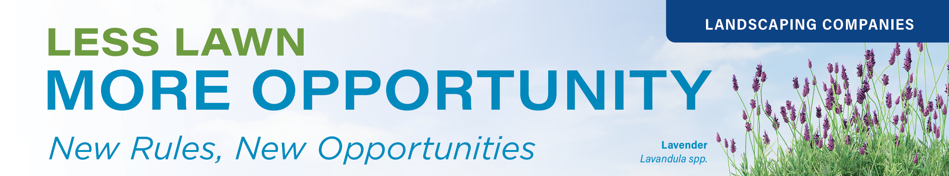

**Marketing Toolkit for Landscape Companies**

***Promote Your Role in Creating Water-Wise Landscapes***

*The following graphics and text are designed to support your business by helping you market your services and expertise in lawn transformation. Below, you can find:*

* *Sample social media posts and graphics you can customize.*
* *A template blog or newsletter post you can share with your commercial clients to explain what’s changing and how your company can help.*

***Note:*** *The white space on the graphics is available for you to customize with your company’s logo and contact information—making it easy to brand and share these materials as your own.*

**Social Media Copy & Graphics**

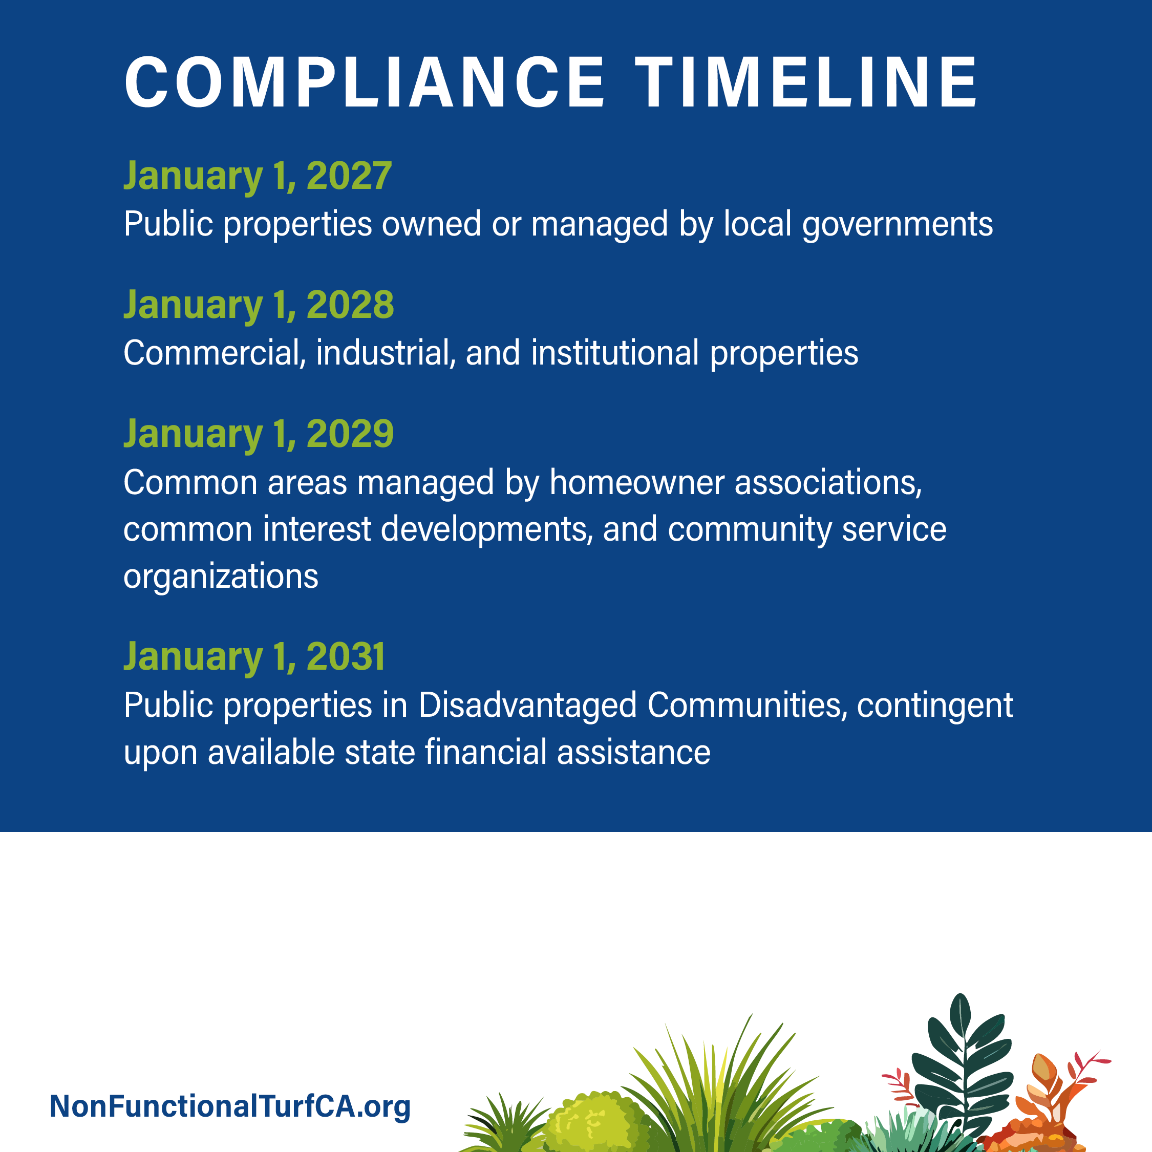

**Graphic: Compliance Timeline**

**COPY:** California’s new law is taking effect soon:

Using drinking water to irrigate nonfunctional lawns on most commercial, industrial, and institutional properties will be prohibited.

We’re here to help transform your nonfunctional lawn into a water-wise landscape - contact us to get started before the deadline.

**Graphic: Less Lawn. More Beauty.**

**COPY:** 🌱Big changes are coming for California lawns🌱

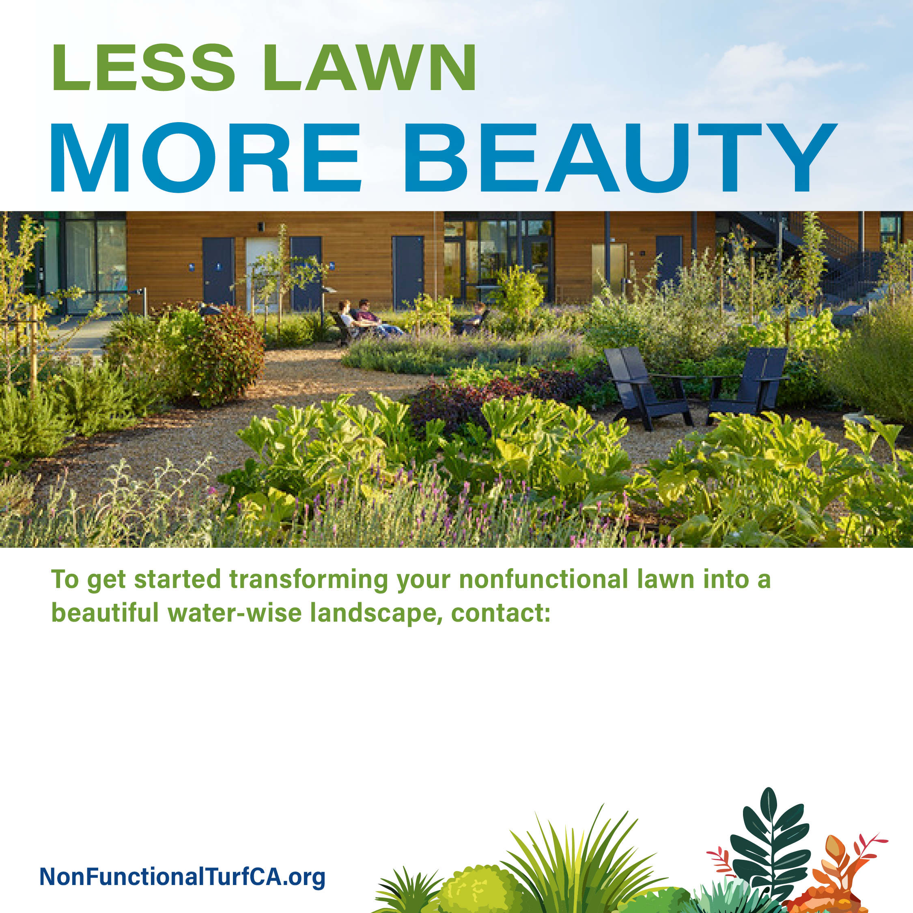  
Under AB 1572, using drinking water to irrigate nonfunctional lawn—like turf in medians, parking strips, or HOA common areas—will soon be prohibited on most commercial, industrial, and institutional properties.

Not sure if your property is affected? I can help you:

* **✅** Identify non-compliant lawn
* **✅** Design a beautiful, drought-tolerant landscape
* **✅** Upgrade irrigation systems
* **✅** Stay ahead of the new regulations

Let’s turn unused lawn into a water-wise space that looks great and saves resources 🌼💧📩

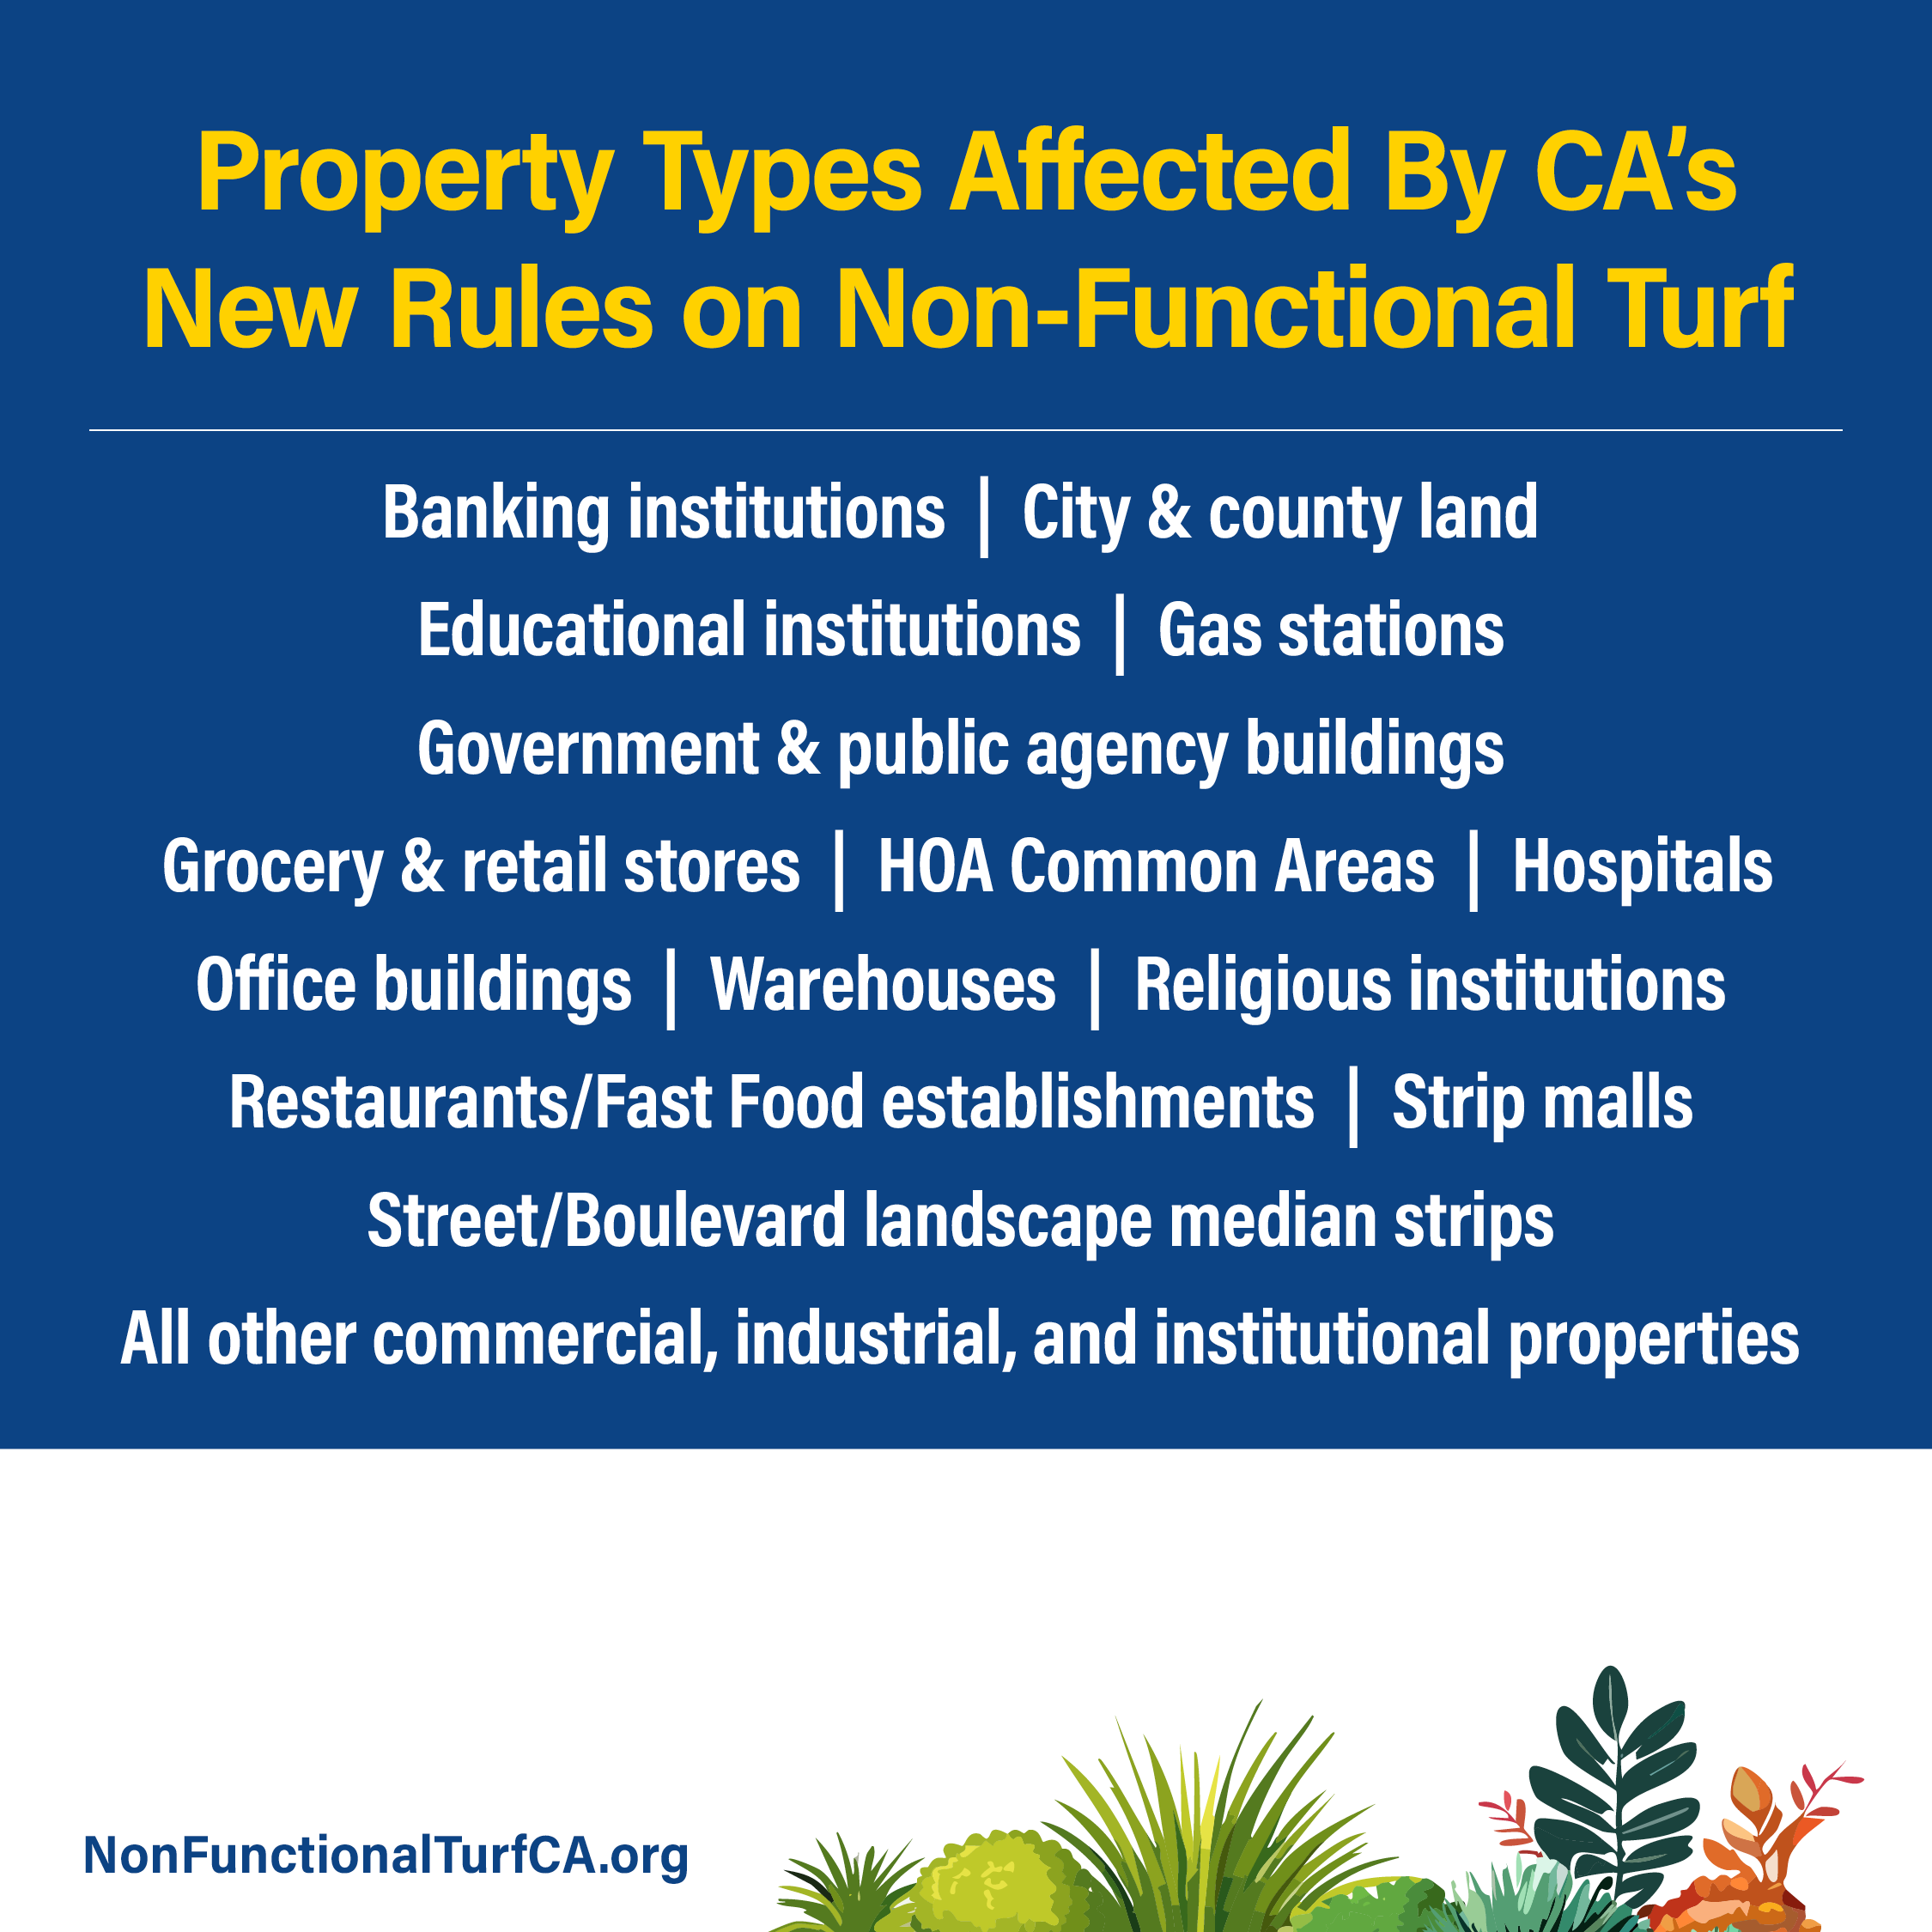

**GRAPHIC: Property Types Affected**

**COPY:** If your property is on this list, California’s new law requires you to stop irrigating nonfunctional lawn with drinking water. Contact us to get started with a beautiful new water-wise landscape

**Blog / Newsletter Post**

**Less Lawn. More Opportunity: What California**’**s New Nonfunctional Lawn Rule Means for You**

A new California law, AB 1572, will soon ban the use of drinking water to irrigate nonfunctional lawns on most commercial, industrial, and institutional (CII) properties—including common areas managed by HOAs. If your property has lawn areas that no one uses—like narrow strips by sidewalks, medians, or turf between buildings—it’s likely considered nonfunctional and subject to the new rules. We know these new regulations may feel like a burden - but non-compliance can result in fines and other enforcement actions. The good news? We can help. Together, we can transform underused lawn areas into vibrant, functional landscapes that meet the rules, save water, and enhance your property’s appeal. Remember too - these rules don’t apply to commercial properties using recycled water on their lawns, or to residential properties.

Don’t wait! Acting early gives you more flexibility, access to rebates, and priority scheduling. Plus, you’ll avoid rising installation costs as demand increases statewide. Transforming nonfunctional lawn may be eligible for generous rebates in many parts of the state. Our team can help you navigate the paperwork, secure funding, and maximize your return on investment

**Key Dates to Know**

2027 – Public agency properties

2028 – Commercial, industrial, and institutional

2029 – HOA common areas, common interest developments, and community service organizations

2031 — Disadvantaged Communities (or once funding is available)

Note: You don’t have to remove the turf, but you will have to stop watering it with potable water.

**How I Can Help**

Managing one property or many? We’ve got you covered. We’ll help you get ahead by starting with site assessments, step-by-step conversion plans, and expert landscape design to create water-wise landscapes that are ready for the future. Our job is to make this transition smooth, smart, and successful for you. Whether it's identifying the areas that are affected, helping you design a more sustainable landscape, or upgrading your irrigation system—I’ll walk you through every step.

* Identify areas affected by the new law
* Design a beautiful, low-water alternative
* Install efficient irrigation systems
* Provide maintenance to keep things thriving

This is a great opportunity to reimagine your outdoor space—not just to meet requirements, but to create something that looks better, works better, and uses less water. We can incorporate:

* Native and low-water plants with year-round interest
* Shade trees, shrubs, and groundcovers
* Seating areas, pathways, and gathering zones
* Features like swales or rain gardens that manage water naturally

For more information on the new regulations, visit [nonfunctionalturfCA.org](http://nonfunctionalturfCA.org). If you’re ready to explore your options or have questions, I’m here to help every step of the way. — [Landscaper Name, Landscaping Company], CA Licensed Landscape Professional

