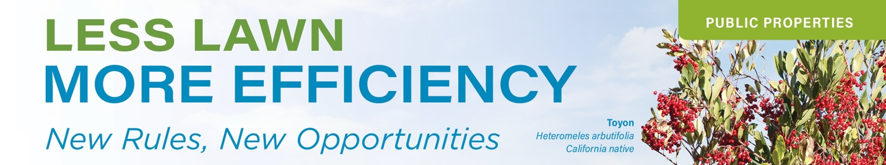

This document is designed to guide municipalities seeking funding to cover the costs of transitioning nonfunctional lawns into water-wise landscapes.

Grant Funding Guidance

Grant Funding 101
As you plan and envision transforming your nonfunctional lawn areas, be sure to research state and federal grants to help cover some of the expenses. Grant funding can be limited and is often distributed on a first-come, first-served basis.

These are tips designed to help you as you begin the process of creating new water-wise landscapes.

Available Resources
Look for information on funding opportunities at:
- NonFunctionalTurfCA.org: The California Water Efficiency Partnership (CalWEP) is collecting and posting information about rebates and grants on the website. Additionally, review CalWEP’s Smart Rebates program for other potential rebates that may be applicable.
- Grants.ca.gov is an online resource developed by the California State Library that lists all of the grants and loans offered by California state agencies.
- Grants.gov is a database designed to help applicants find and apply for federal grants.
- The California Financing Coordinating Committee combines federal and state resources, serving as a one-stop shop for available grants, loans, and bond financing for infrastructure projects. They hold free funding fairs statewide each year. https://www.cfcc.ca.gov
- Consider pursuing nontraditional funding streams:
  - Partner with the local water provider or utility to explore enhanced funding opportunities, such as utilizing drought surcharge credits for demonstration projects.
  - Climate resilience or heat adaptation grants (CalFire Urban Forest grants).
  - SB 1383 compliance (reduction of organic waste from lawn maintenance in landscaping) as a co-benefit.
  - Apply for regional transportation or air quality funds when redesigning streetscapes with lawn removal.
  - Coordinate with stormwater programs to co-fund bioswales, rain gardens, or infiltration areas where lawn is removed.
  - Research grants from private foundations.
Best Practices Checklist
- Create a complete summary of locations with nonfunctional lawn. Prioritize areas based on high water usage, visibility, and greatest impact.
- Create a phased plan to transform nonfunctional lawn areas with water-wise landscapes.
- Research available grants and funding opportunities to find those that meet your needs. Be sure to check the deadlines for submission and eligibility requirements.
- Develop your application. Consider partnering with other local agencies and departments, such as the Fire Department and the Local Water Provider.
- Collaborate with community-based organizations, such as Native Plant Societies, UC Master Gardeners, and Botanical Gardens, or local service groups, such as Scouting America.
- Contact your local water provider to determine what resources and support they can offer for planning and implementation, as well as assistance in quantifying water savings for identified sites.
- Be aware of all filing requirements and due dates for deliverables. Maintain strong lines of communication with the grant manager. They are there to help you succeed.
- Properly document all of your expenses. Make sure all outside contractors and suppliers maintain detailed invoices.
- Document the transformation by taking photos and videos before, during, and after the process.
- Develop educational materials using grant dollars to inspire landscape transformation by community leaders, businesses, and homeowners.

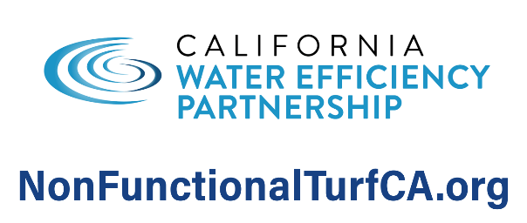
Feel Free to Add Water Agency Logo]
Website: [Insert URL]
Phone: [Insert Number]
Rebate Info: [QR Code or Link]

