
This document is designed to help city planning departments incorporate the requirements of AB 1572 into the project review process. They are meant to work in tandem with local ordinances and requirements.

Planning & Plan Check Guidance: Implementing AB 1572

California law (AB 1572) prohibits the use of potable (drinking) water for irrigation purposes on nonfunctional turf—lawns that serve no recreational or community purpose at commercial, industrial, and institutional (CII) properties, including common areas managed by homeowner associations (HOAs).

This legislation does not apply to single-family or multi-family residential properties, cemeteries, areas irrigated with recycled water, or areas requiring an exception for tree health and situations requiring an exception to address an immediate health and safety need.

Background: What the Law Requires
AB 1572 prohibits the use of drinking water to irrigate nonfunctional lawns on most non-residential properties, including:
- Public agency properties (by January 1, 2027)
- Commercial, industrial, and institutional (CII) sites (by January 1, 2028)
- Common areas of homeowner associations (by January 1, 2029)

This law works in tandem with California’s Model Water Efficient Landscape Ordinance (MWELO), which sets design standards for new and renovated landscapes. AB 1572 mandates where potable water can be used, while MWELO governs how landscapes must be designed.

Actions to Take

1) Update Land Use Applications and Application Checklists
Planning Departments should incorporate questions focused on compliance with AB 1572 into base applications and land use application checklists. For example:
- CII Site Plan:
  - Identify all areas of the landscape on the property and their intended purpose.
  - Determine whether potable or non-potable water is used or planned to be used for these areas.
  - Do the functional lawn areas meet the requirements of California’s Model Water Efficient Landscape Ordinance (MWELO)?

2) Update Codes and Requirements
- To align with the requirements of AB 1572, cities and counties must update their local ordinances, codes, and landscape design guidelines by January 1, 2027, to reflect the restrictions on potable water use for nonfunctional lawns. Additionally, they must prohibit nonfunctional lawns in new or retrofitted public sites and private CII landscapes.
- Require compliance with the Model Water Efficient Landscape Ordinance (MWELO) with local amendments enforcing stricter limits on lawn.
- Direct facilities departments to:
  - Prioritize the removal of nonfunctional lawn not used for active recreation and its replacement with low-water-use and native plants and a high-efficiency irrigation system.
  - Adopt a no-potable-irrigation rule for nonfunctional lawn on municipal property.
  - If keeping the areas of nonfunctional lawn is a priority, switch to recycled water or harvest stormwater where possible.

3) Review Site Plans and Landscape Documents
Plan reviewers should begin reviewing all submitted plans for compliance with AB 1572. Staff should:
- Provide applicants with preliminary information on the requirements for AB 1572.
- Review the applicant’s submitted plans and flag any areas of nonfunctional lawn.
- Require adjustments to plans that do not meet the law’s requirements.
- Inspect the landscape project to ensure its compliance with AB 1572 and MWELO.
4) Develop Outreach Materials and Share Requirements
Planning Departments should proactively inform all relevant city and county departments, as well as impacted parties, developers, landscape designers, and irrigation installers about AB 1572 and its restrictions.
- Provide guidance on:
  - Nonfunctional lawn identification
  - Water-wise design techniques
  - Irrigation conversion best practices
  - Protecting trees in areas with a nonfunctional lawn

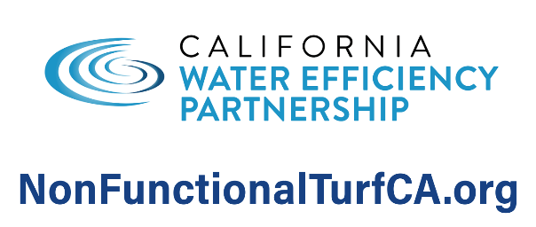
[Feel Free to Add Water Agency Logo]
Website: [Insert URL]
Phone: [Insert Number]
Rebate Info: [QR Code or Link]

