

Newsletter Articles for HOA Use

Below are sample newsletter articles that Homeowners Associations (HOAs) can adapt and share with residents about the changes coming to the areas of nonfunctional lawn in the HOA common areas.. Each story is written to explain upcoming changes to common areas where nonfunctional lawn will be replaced. You may:
- Insert the name of your community where indicated.
- Adjust wording to match your HOA’s style and tone.
- Pair the stories with photos, graphics, or plant lists to help residents visualize the changes.

These stories are intended to help residents in your HOA understand why the changes are happening and highlight the benefits of transitioning to water-wise landscapes.

A New Look for Our Common Areas
You are going to see some exciting and vibrant changes coming to the name of the community. California has passed a law that prohibits the use of potable (drinking) water to irrigate areas of lawn that are purely decorative, such as narrow strips along walkways, medians, or entry areas.

We are going to replace these areas of lawn with water-wise landscapes utilizing low-water and native plants. The new landscapes will not only require less water but also support local wildlife and add a more dynamic and colorful look to our common areas.

It is an opportunity to create a distinct visual identity, increase the curb appeal, and serve as inspiration for others.

New Vibrant, Water-Wise Landscapes for Our Common Areas
A new look is coming to the name of the community. We will soon be transforming the purely decorative areas of lawn into colorful, water-wise landscapes filled with water-wise and native plants.

The new landscapes will require less water and fewer pesticides. Our new landscapes will provide food and shelter for birds, butterflies, and other pollinators, and feature a variety of shapes and colors that will change with the seasons.

We think you’ll be excited and interested to see how things grow.

Creating a New Vision for Our Landscapes
California has passed a law (AB 1572) that requires HOAs to stop watering areas of lawn that are purely decorative and do not serve a recreational or community gathering by January 1, 2029.

The law is rolling out in phases, with local governments having to stop watering by January 1, 2027, followed by commercial properties by January 1, 2028, and then HOAs.

We are taking this opportunity to design landscapes that not only use less water, but that also embrace the beauty of low-water native plants and provide sustenance and shelter for birds, bees, butterflies, and other native pollinators.

We will be creating areas that capture stormwater, require fewer pesticides, and add more shade. It’s an exciting opportunity to rethink our shared environment and create a sustainable vision for the future.

* We recommend sharing landscape plans and plant lists with HOA residents, as well as laying out the timeline for the changes.

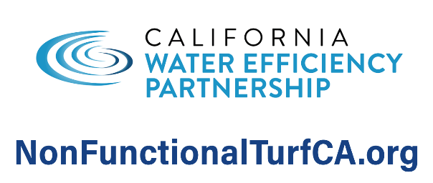
[Feel Free to Add Water Agency Logo]
Website: [Insert URL]
Phone: [Insert Number]
Rebate Info: [QR Code or Link]

